**Partnership**

**Linking the Anglican Churches of Poole & North Bournemouth Deanery**

**with the Diocese of Wau, South Sudan, since 2011**

POOLE-WAU

Charity name: Poole-Wau Partnership Charitable Trust

Charity number: 1147425

Charity E-mail Address: churchoffice.1@btconnect.com

Charity Registered Address: 38 Landers Reach, Lytchett Matravers, Poole, Dorset BH16 6NB

The principal aim of the Poole—Wau Partnership is to support the work of Wau Diocese in all its different forms, including financial support for practical projects. The Partnership was formally established in February 2011, inspired by a visit to the UK in 2010 by Rt Rev Moses Deng Bol, Bishop of Wau (now also Archbishop of Northern Bahr el Ghazal province) and embodying his vision of a link based on Acts 2, 42-47 in which the partners strengthen each other spiritually, share talents and gifts and share resources.

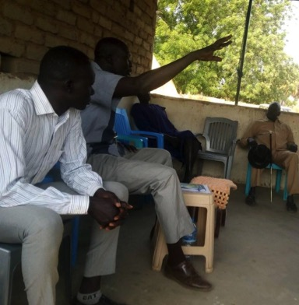

**South Sudan** became independent from Sudan only in 2011 and the country suffered a civil war from 2015 to 2018. Life in South Sudan is very different from anything we are used to in the UK, and the country faces enormous problems.

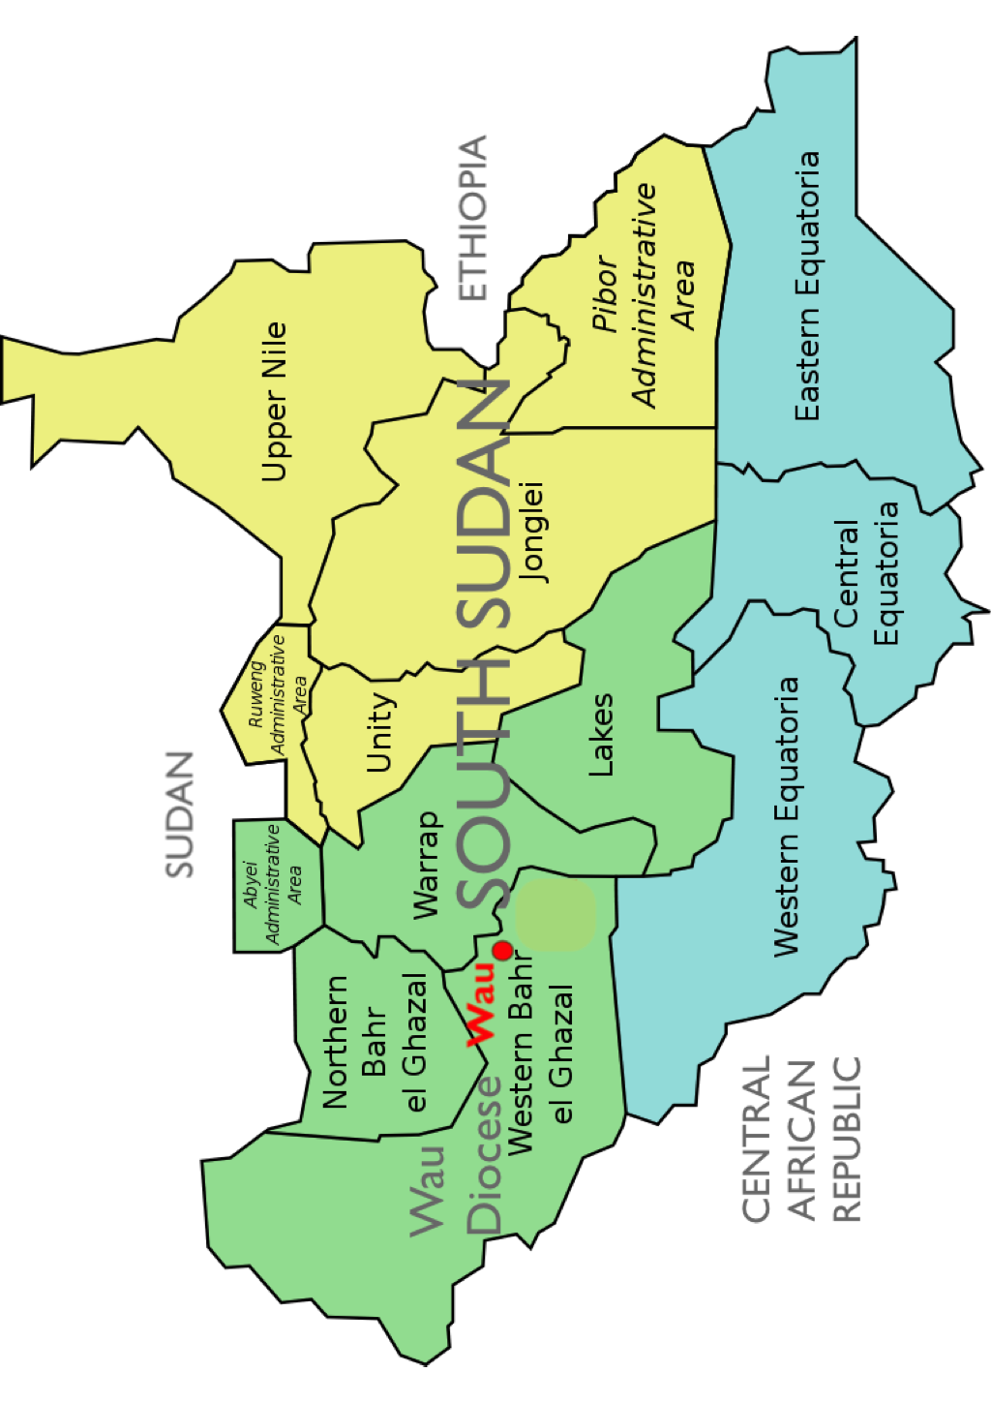 There is limited education and healthcare, dependence on imported food supplied by the UN, frequent flooding and the legacy of decades of war and insecurity.

The photo shows Archbishop Moses at a meeting of community leaders at St Peter’s Cathedral in Tonj Diocese in February 2021.

He published a book on the role of the church in nation-building in 2019 and he has been working hard to rebuild trust, stability and peace in the country.

**Wau** is South Sudan’s second city and is about the same size as Poole, with a population of around 150,000. It is about 400 miles from the capital, Juba. Wau Diocese is part of the Episcopal (Anglican) Church of South Sudan and covers Western Bahr el Ghazal state in the north-western part of South Sudan.

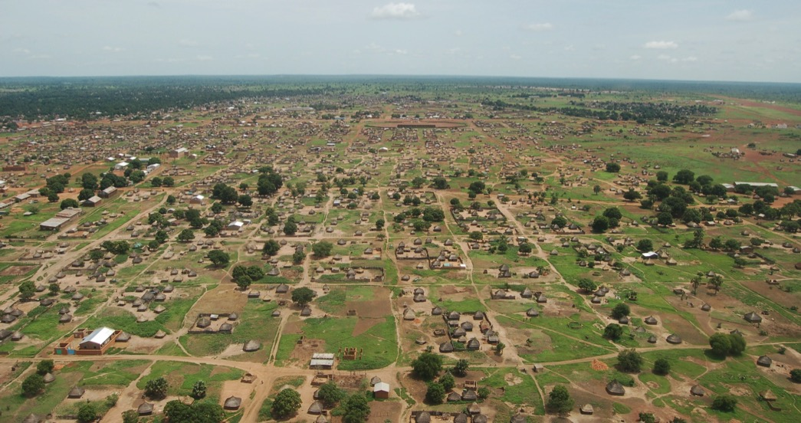

**Poole-Wau Partnership** aims to share our lives, different as they are in many ways, with our sisters and brothers in the Diocese of Wau - by means of prayer, by Facebook and e-mail, by visiting when circumstances allow, all of which can work both ways; and by financial aid which is inevitably one way. PWP has raised over £250,000 during its first ten years to support Wau Diocese. We depend principally on support from the 22 Anglican churches of Poole & North Bournemouth Deanery, which covers all of Poole, plus Lytchett Minster, Lytchett Matravers, West Howe, Kinson and Ensbury Park. We also carry out a limited number of fundraising events, including the annual ‘Holes Bay Challenge’ 7-mile walk, which raised £4000 in 2020. We hold monthly prayer meetings and keep our supporters informed by means of a bi-monthly Newsletter and monthly Prayer Letter.

**PWP Contact Details**

The Poole-Wau Partnership,

St Dunstan’s Church Office,

Poole Road,

Upton BH16 5JA

01202 624622

e-mail: [churchoffice1@btconnect.com](mailto:churchoffice1@btconnect.com)

Chair: Jeff Neagle; [jefferyneagle92@gmail.com](mailto:jefferyneagle92@gmail.com)

Newsletter Editor: Mark Rathbone; [mark.rathbone@phonecoop.coop](mailto:mark.rathbone@phonecoop.coop)

**Latest News**

To receive our newsletter, please e-mail Mark Rathbone at [mark.rathbone@phonecoop.coop](mailto:mark.rathbone@phonecoop.coop) to have your name added to the e-mailing list. To receive our regular Prayer Letter, please e-mail Sue Walkden at e-mail Prayer Letter at [suebwalk@gmail.com](mailto:suebwalk@gmail.com). To see our latest Newsletter **CLICK HERE.**

**PWP Projects**

The Partnership has supported a number of different projects in Wau over the past decade, some long-term, others to meet pressing emergencies. Here are details of a few of them.

**St John’s College**

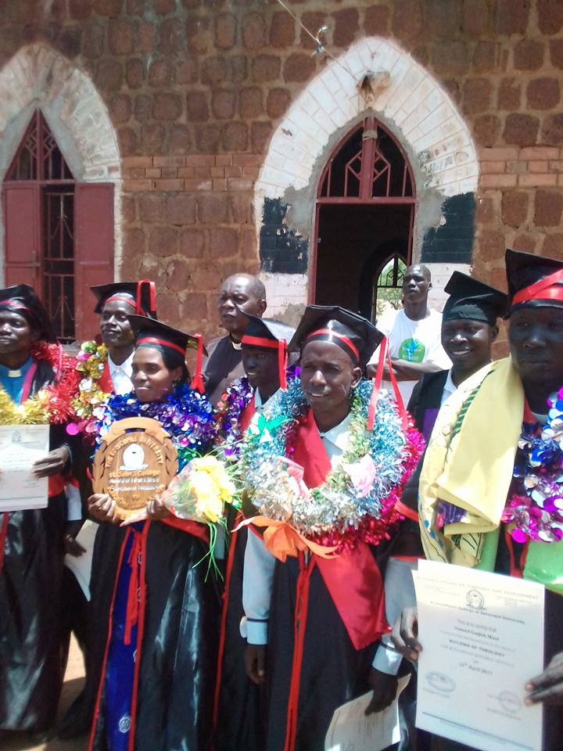There are over 400 clergy in Wau Diocese, but until recently, many of them had not even completed Primary School level education. St John’s College was set up by the Diocese to deal with this situation, and from a small start with 3 students in 2011, it now has over 400, studying Business Studies and Education, as well as Theology.

Support for St John's has been our main project for the past few years, starting in 2015, when we pledged £3,600 per year. We have been helping to pay the salaries of Theology teachers and the amount of our support has now risen to £17,000 per year. During the Covid-19 pandemic in 2020, St John’s College had to shut for six weeks, but support from PWP enabled the college to continue paying teaching staff, ensuring that it did not lose experienced teachers.

Women’s ministry is an important priority for Wau Diocese, and St John’s College does all it can to enable women to train. A major incentive for women to enrol is that all their meals are paid for, which costs £300 a year for each student. In Poole, an annual Garden Party run by the Mothers’ Union has contributed around £500 - £600 per year to the Women’s Funds, with more support from individuals.

In November 2020, we published an article by one St John’s Theology student, Jino Malual Mabuoc. He wrote that, *“I have found that studies at St. John’s College have impacted me and changed my life. My knowledge, believing, understanding of social affairs and the role of leadership have all changed and inspired me. I’m now ready to expand the Church’s Ministry by teaching my people. Through St. John’s I am now able to offer accurate knowledge and life skills to help church members.”*

**Diocesan Guest House**

When we asked Bishop Moses in 2012 whether there were any projects we could get involved with, he put forward the idea that an old colonial-era house close to the Cathedral could be converted into a Guest House which would provide accommodation for both international and South Sudanese visitors and earn money to support the Diocese. The house belonged to the last British Governor but after years of neglect it was in a very poor state, with leaks to the concrete roof, rotting doors and windows, a veranda that was falling apart, no water supply or flush toilets, and no electricity.

This became our main project from then until it was completed in early 2016: the photos below show the guest house under construction and after completion. When Jeff Neagle and Rev Chris Strain from PWP visited Wau in November 2018, they found the guest house is now a really useful facility where they were able to stay very comfortably. One of the problems that Wau Diocese faces is the lack of practical knowledge in such things as computing, office management, finance, teaching methods in schools, and theological expertise for St John’s College. As well as accommodating short stay visitors, the guesthouse allows international visitors, such as teachers and other professional people, to stay for longer periods and offer training in these and other areas.

PWP also provided £3,800 for a new roof for the Wanyjok Diocesan Office in 2018.

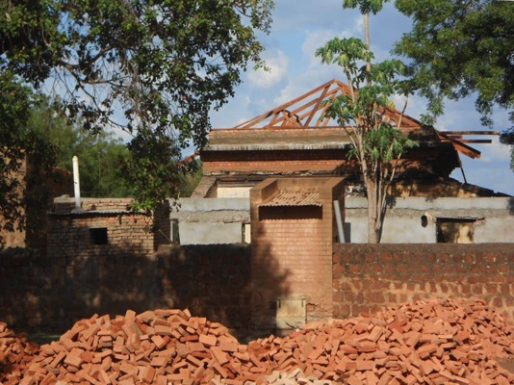**Macintosh HD:Users:markrathbone:Documents:Mark:Poole Wau Partnership:Newsletters:Newsletter 46:Guest House.pdf**

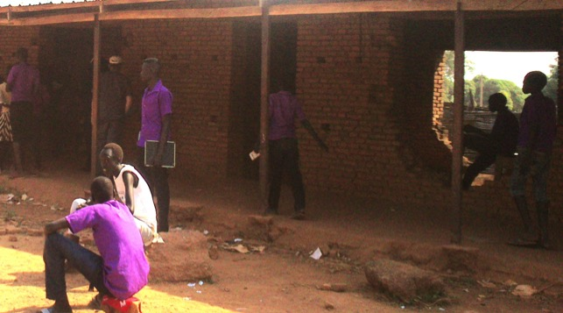**‘Sunday’ Primary School**

In 2019, PWP launched a Lent Appeal to help pay for the completion of this primary school in Wau. The building had been started, but money had run out and there were no windows or doors, and the building was in danger of deteriorating.

The appeal raised enough to pay for the 8 doors and 24 windows to complete the school.

**Chess Club for Kakuma Refugee Camp**

The full implementation of the peace agreement signed in 2018 is taking time to achieve, and many refugees from South Sudan continue to live in camps in Uganda, Kenya, and Ethiopia. In 2019, PWP was approached by Nhial Kheer, a South Sudanese refugee from Wau who has lived in Kakuma Camp in north-west Kenya for the last 15 years. Nhial saw teaching people to play chess as a way of improving inter-tribal relations in the Camp (as well as giving them something worthwhile to do) in the hope that this would carry through to when they eventually return home. With help from Eric Sachs of Poole Chess Club, we were able to send £500 to buy new chess sets and boards, tables and chairs.

**Emergency Food Aid**

Although providing aid is not our primary aim, an example of emergency help which PWP was able to provide to assist with urgent and unexpected needs occurred in 2016. When inter-tribal conflict spread to Wau district, some 5000 internally displaced people from villages in the surrounding area took refuge in the Wau Cathedral compound, shown in the photo below. At first the Cathedral staff had nothing to give them but water. PWP donated £3000 for emergency food aid. *“The way it happened was a small miracle that looked like Poole Deanery was used by the Holy Spirit,”* said Archbishop Moses at the time, as the aid had been sent unasked. *“With this unlooked-for money, the Diocesan staff were able to buy food on the first, second and third days. The Church alone was able to feed them - no other source of money was available.”*

